Title, Times New Roman 14 Bold, Capitalize Each Word

Author One^{1*}, Author Two¹, Author Three²

¹High School Name, City, State, Country, ²High School Name, City, State, Country

*Corresponding Author: Provide email address

Advisor: Full Name of the leading advisor, Full Name of the Institutional Affiliation, email address

Abstract

Every manuscript should include an abstract which has a single paragraph with less than 250 words. Do not include tables, figures, and citations. Abstract may include current issues related to the research, hypothesis, objectives, brief procedure, and important findings through the research.

Keywords: Provide 3 - 7 Keywords, Keyword1, Keyword2, Keyword3

- Introduction (Heading 1; Use this style for heading 1)

This template shows instructions to prepare the manuscript. The component of the paper includes Abstract, Introduction, Materials and Methods, Results, Discussion, Conclusion (optional), and References. US English is the official language for the JRHS.
0.25-inch indentation for all content. One space between each heading and the first sentence. No space between paragraphs. All body needs to be numbered as shown in this template.
Authors discuss current and previous related works performed by other researchers. In addition, the significance of the research, hypothesis and objectives are needed to be addressed in the introduction.

  - Abbreviation (Use this style for heading 2)

Make the expanded form of an abbreviation for the first use, and immediately after, provide abbreviation in parenthesis.

Page Setup (Use this style for heading 3)

The 1-inch margin for all sides, top and bottom (normal in MS WORD margin). The body text font is times new roman with a size of 10 and single-spaced.

- Materials and Methods

This section is for experimental setups and procedures. All descriptions should be detail enough for other researchers can follow the procedures. This section should be descriptive, and no bullet/number formats are accepted.

- Results

This section shows experimental data, measurements, and observations. No explanations or interpretations are expected in this section and those information needs to be addressed in the discussion section. All tables, figures, and equations should be located in the proper positions and all descriptive explanation needs to be referred from the context in the body.

  - Table

Table caption should be located right above the table with left alignment. NO image file can be used as a table. The table needs to be created using the MS WORD table drawing function or similar tools.

  - Equation

To create an equation, use MS WORD equation editor or similar tools (such as MathType and GoogleDoc equation ). Do not encourage to draw equations. Equation locates in the middle and below is a sample.

 | $$2x=\frac{Z^{2}}{(3y-5)}$$ | (1)

Where x, y, and z are ….., respectively.

  - Figure

The figure should be located in the proper position referred in the manuscript. All figures should be comprehensible to readers and simple enough to provide clear information related to the research. An example is shown below.
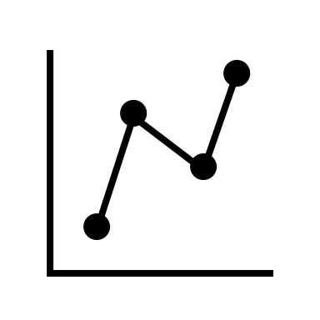
Figure 1. Figure caption should follow the figure and the first letter needs to be capitalized. If you reproduce the third-party published information, you need to disclose the source and obtain permission if needed.

- Discussion

In this section, observed results and data should be interpreted concisely. In addition, the authors need to explain the significance of the research findings and revisit the hypothesis described in the introduction.

- Conclusion

This is an optional section and authors can restate the important findings throughout the research.

Acknowledgment
This is an optional section and is used to appreciate individuals who support/encourage the research performance.

Disclosure
When authors include non-high school students, the advisor should disclose each author’s contribution including research performance and preparation of the manuscript.

References
Follow the guideline as shown in here. If there is no information you can’t find, follow APA format.

One space between each reference.

In article, up to two authors, use last name(s) and year in parenthesis. Example; (Doe, 2020), or (Doe and Smith, 2020)

In article, three or more authors, use first author last name and year in parenthesis. Example; (Doe, et al., 2020)

Include DOI information at the end if available. Detailed information can be found under author information section in the journal website. https://www.journalresearchhs.org/author

